**22339408**

**E Zungula**

**Smart Campus Shuttle System**

This project models a campus shuttle system as a directed graph. We identified 10 key campus locations and mapped the shuttle paths based on real-world campus flow. The project includes a directed graph diagram, an adjacency matrix, an adjacency list, and Python code to simulate the system**.**

**List of locations (Nodes)**

1. Admin Building

2. Engineering Block

3. Science Labs

4. Library

5. ICT Department

6. Residence A

7. Residence B

8. Cafeteria z

9. Sports Complex

10. Main Entrance

**List of Connections(Edges)**

Admin Building → Library

Library → ICT Department

Library → Sports Complex

ICT Department → Engineering Block

Engineering Block → Science Labs

Science Labs → Cafeteria

Cafeteria → Residence A

Residence A → Residence B

Residence B → Main Entrance

Main Entrance → Admin Building

**Directed Graph**

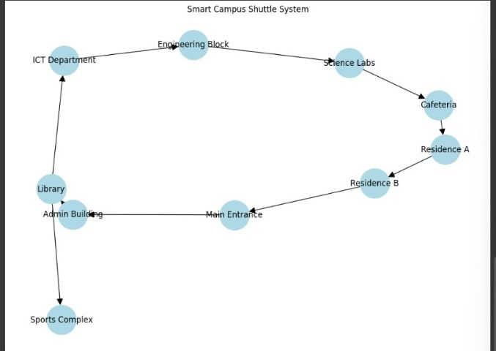

**Adjacency Matrix (Table)**

|  |  |  |  |  |  |  |  |  |  |  |
| --- | --- | --- | --- | --- | --- | --- | --- | --- | --- | --- |
|  | 0 | 1 | 2 | 3 | 4 | 5 | 6 | 7 | 8 | 9 |
| 0 | 0 | 0 | 0 | 1 | 0 | 0 | 0 | 0 | 0 | 0 |
| 1 | 0 | 0 | 1 | 0 | 0 | 0 | 0 | 0 | 0 | 0 |
| 2 | 0 | 0 | 0 | 0 | 0 | 0 | 0 | 1 | 0 | 0 |
| 3 | 0 | 0 | 0 | 0 | 1 | 0 | 0 | 0 | 1 | 0 |
| 4 | 0 | 1 | 0 | 0 | 0 | 0 | 0 | 0 | 0 | 0 |
| 5 | 0 | 0 | 0 | 0 | 0 | 0 | 1 | 0 | 0 | 0 |
| 6 | 0 | 0 | 0 | 0 | 0 | 0 | 0 | 0 | 0 | 1 |
| 7 | 0 | 0 | 0 | 0 | 0 | 1 | 0 | 0 | 0 | 0 |
| 8 | 0 | 0 | 0 | 0 | 0 | 0 | 0 | 0 | 0 | 0 |
| 9 | 1 | 0 | 0 | 0 | 0 | 0 | 0 | 0 | 0 | 0 |

**Legend (Index Mapping)**

0: Admin Building

1: Engineering Block

2: Science Labs

3: Library

4: ICT Department

5: Residence A

6: Residence B

7: Cafeteria

8: Sports Complex

9: Main Entrance

**Add the adjacency list (Hash Map Format)**

graph = {

"Admin Building": ["Library"],

"Library": ["ICT Department", "Sports Complex"],

"ICT Department": ["Engineering Block"],

"Engineering Block": ["Science Labs"],

"Science Labs": ["Cafeteria"],

"Cafeteria": ["Residence A"],

"Residence A": ["Residence B"],

"Residence B": ["Main Entrance"],

"Main Entrance": ["Admin Building"],

"Sports Complex": []

}